**Entry into the Stockholm Junior Water Prize (2019)**

**Machine Learning Classifiers to Predict Outbreaks of**

**Toxic *Karenia Brevis* Blooms on the West Florida Shelf**

**Marvin F. Li**

**James M. Bennett High School**

**Salisbury, Maryland 21804**

**United States**

**I. Abstract** Harmful Algal Blooms (HABs) have increased in frequency, magnitude and impacts around the world. HABs cause massive fish kills and create human health problems by poisoning seafood, contaminating water supplies, and producing aerosolized toxins. During 2017 and 2018, blooms of toxic dinoflagellate *Karenia brevis* swept over West Florida coast, resulting in thousands of tons of dead fish and marine life, numerous respiratory-related hospitalizations, and hundreds of millions of dollars in economic damage. In this research, I analyzed long-term monitoring data and developed machine learning classifiers to predict *Karenia brevis* blooms. I explored three machine learning algorithms: Support Vector Machine (SVM), Naive Bayes classifier (NB), and Artificial Neural Networks (ANN). SVM has the highest classification accuracy, with an overall accuracy of 78%. I showed that northerly winds generate coastal upwelling and onshore transport of *Karenia brevis*, while large river flows supply nutrients to fuelthe blooms near the coast. My research suggests that increasing precipitation in a warming climate will increase *Karenia brevis* blooms but reducing riverine nutrient loading can lower the bloom occurrences on the West Florida Shelf.

**II. Table of Contents**

1. Introduction 3

2. Materials and Methods 6

3. Results 9

4. Discussion 13

5. Conclusions 15

6. References 16

**III. Key Words**

Red tide, harmful algal blooms, Karenia brevis, West Florida Shelf, eutrophication, coastal upwelling, river discharge, nutrient loading; classification, machine learning, support vector machines, artificial neural network, naive bayes.

**IV. Abbreviations and Acronyms**

HABs – Harmful Algal Blooms  
*K. brevis* – *Karenia brevis*  
FWRI – Fish and Wildlife Research Institute

WFS – West Florida Shelf  
USGS – United States Geological Survey  
NOAA – National Oceanic and Atmospheric Administration  
NDBC – National Data Buoy Center

SVM – Support Vector Machine  
NB – Naive Bayes  
ANN – Artificial Neural Network

TN – Total Nitrogen Loading

TP – Total Phosphorous Loading

**V. Acknowledgements**

Dr. Patricia Glibert of Horn Point Lab, the University of Maryland Center for Environmental Science, provided *Karenia brevis* data to me. I met with Dr. Glibert four times and communicated with her through emails. I did the model development and data analysis on my own and provided my results to Dr. Glibert for comments. I would like to thank Dr. Glibert for her encouragement and advice on this project. River discharge and nutrient concentration data were downloaded from the United States Geological Survey and Tampa Bay Water Atlas. Wind and temperature data were downloaded from the National Data Buoy Center.

**VI. Biography**

My name is Marvin Li, and I am a sophomore at James M. Bennett High School in Salisbury, Maryland. My interests include math and computer science, environmental science, machine learning and data science, student government, and trivia.

In 7th grade, I went on a field trip to the Chesapeake Bay. The water was startling murky and brown, and I wondered how plants and animals like sea grasses and oysters could survive under such poor light conditions. I became enthralled by the water quality problem in the Chesapeake Bay. I wanted to help and contacted a professor at the University of Maryland Center for Environmental Science. In that project, I developed machine learning algorithms for satellite remote sensing of optically complex coastal waters. I won national awards for this research project: Google Science Fair State Winner (2019), one of twenty Davidson Fellows in the United States (2018), 4th Place Grand Award Winner and 2nd Place Special Award from the American Statistical Association at the Intel International Science and Engineering Fair (2018), and Broadcom Masters Semifinalist (2017). When I learned about the massive toxic red tide on the West Florida Shelf last year, I wanted to learn more. I contacted Professor Dr. Glibert and initiated this research project.

**1.** **Introduction:**

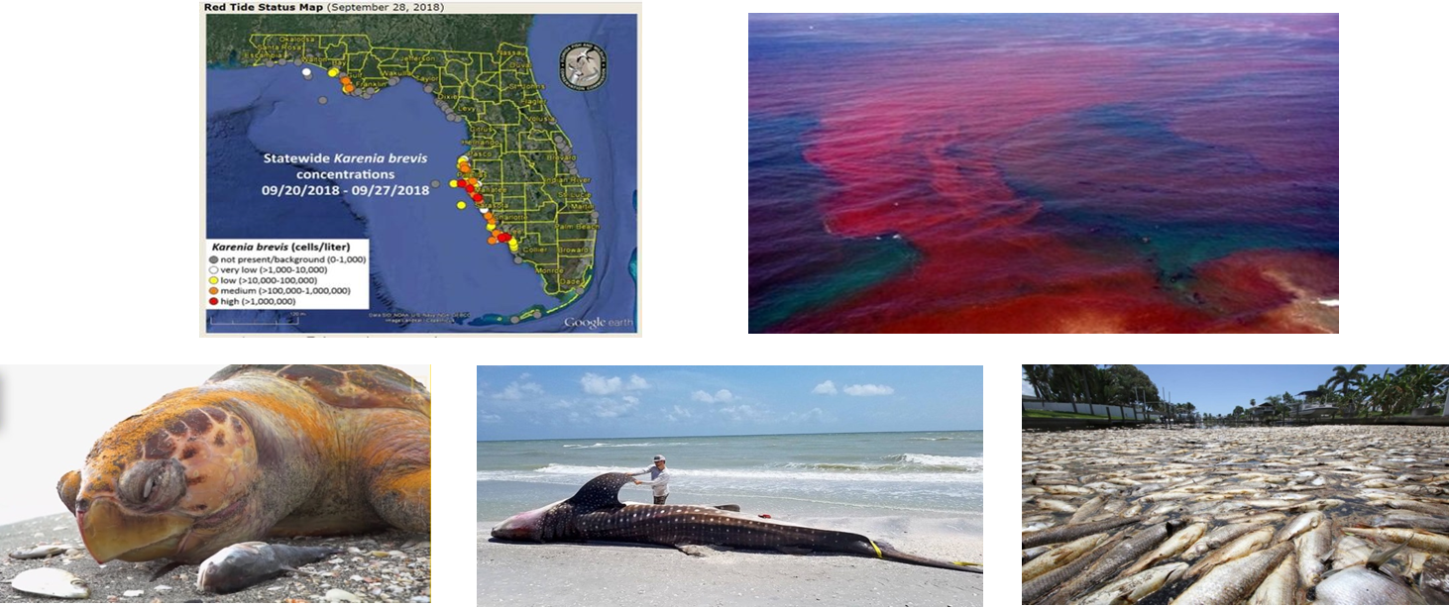

**Figure 1. (a) Map of *K. Brevis* blooms on the West Florida Shelf in September 2018. (b) Photo of the *K. Brevis* red tide. (c)-(e) Dead marine mammals and fish killed by the red tide (courtesy of Florida Fish and Wildlife Commission).**

(c)

`

(d)

(e)

(a)

`

(b)

Over the past few decades, Harmful Algal Blooms (HABs) have increased in their frequency, magnitude, and economic and health impacts around the world (Anderson et al. 2002, Glibert et al. 2005, Heisler et al. 2008, Glibert and Burford 2017). HABs can cause massive fish kills, devastate fisheries and coastal economies, and create human health problems by poisoning seafood, contaminating water supplies, and producing aerosolized toxins (Landsbery 2002, Backer and McGullicuddy 2008, Fleming et al. 2011, Burkholder et al. 2018). An important cause of the increasing severity of HABs is eutrophication from sources like agricultural runoff and wastewater sewage. Increasing precipitation in a warming climate can compound the problem: runoff from heavy precipitation events can generate strong pulses of nutrient discharge into coastal waters (Sinha et al. 2017). During 2017 and 2018, blooms of toxic dinoflagellate *Karenia brevis* swept over 130 miles of West Florida coast, resulting in thousands of tons of dead fish and marine life, numerous respiratory-related hospitalizations, hundreds of millions dollars in economic damage, and a declaration of a state of emergency in seven counties in Florida (**Figure 1**, Wei Haas and Depp 2018, Visser 2018). There is an urgent need to understand what drives *K. brevis* blooms and predict its outbreaks on WFS.

*Karenia brevis* blooms are affected by a variety of physical and biological processes (Walsh et al. 2006, Steidinger 2009, Heil et al. 2014, Maze et al. 2015). Seed blooms of *K. brevis* are initiated far offshore and then transported to near-shore waters where they can flourish and persist for months. Wind-driven coastal upwelling is thought to play a role in the bloom initiation and transportation of cells across the shelf via the bottom Ekman layer (Liu and Weisberg 2012, Mayer et al. 2017), but strong upwelling over the shelf break may suppress *K. brevis* blooms by favoring faster growing diatoms (Weisberg et al. 2014, Liu et al. 2016). *K. brevis* moves through waters with a wide range of nutrient concentrations: from nutrient impoverished offshore waters to nutrient-rich estuarine and coastal waters. It is a physiologically versatile organism that utilizes a number of nutrient sources, including nitrogen-fixing cyanobacterium *Trichodesmium,* riverine nutrient inputs, and nutrient releases from decaying fish killed by the blooms (Hu et al. 2006, Vargo et al. 2007, Lenes et al. 2008, Heil et al. 2014). There is some evidence that *K. brevis* bloom events have been increasing over time.Brand and Compton (2007) examined the Florida state HAB database (Haverkamp et al. 2004) and concluded that *K. brevis* bloom concentrations increased 15-fold from the 1950s to the 1990s. They attributed this dramatic increase to increasing coastal development and eutrophication. Despite progress in understanding of *K. brevis* blooms, many questions remain unanswered. How do physical and biological processes control the magnitude and frequency of the blooms? What are the impacts of extreme precipitation events and associated nutrient loading from rivers? Can nutrient management reduce the frequency of *K. brevis* blooms on WFS (Heil and Steidinger 2009)? Will climate change lead to more frequent HABs in the future?

The current capability to predict HABs is limited (Glibert et al. 2010). NOAA maintains an operational forecasting system that provides 3-5 day outlooks for the potential level of respiratory irritation at locations that can be expected from *K. brevis* blooms. These predictions are based on satellite remote sensing of chlorophyll *a* (Stumpf et al. 2003) and in-situ sampling of *K. brevis* concentrations on WFS, as well as physical parameters monitored from buoy data (e.g., prevailing winds). The goal of the NOAA forecasts is to inform managers and the public of coastal sites where public health may be compromised from *K. brevis* Blooms (Stumpf et al. 2009). Although important in the daily protection of human health, these forecasts are not designed to produce longer-term predictions of bloom occurrences, nor can they be used to understand how and why outbreaks of *K. brevis* blooms occur under certain environmental conditions.

*Karenia brevis* concentration and related environmental conditions have been regularly monitored on WFS over the past few decades. Local and state monitoring of *K. brevis* blooms in recent decades has resulted in extensive, georeferenced *K. brevis* concentration data housed in the Florida HAB Historical Database at Fish and Wildlife Research Institute (FWRI). This data set can be analyzed for annual spatial and temporal patterns in *K. brevis* blooms. In addition, United States Geological Survey (USGS) maintains a large number of water gauge stations at rivers throughout Florida, measuring discharge and water quality parameters. On WFS and in the eastern Gulf of Mexico, National Oceanic and Atmospheric Administration (NOAA) deployed several buoys to provide continuous measurements of winds, air pressure, temperature and water level. This rich array of monitoring data provides a great opportunity to identify possible connections between environmental conditions and *K. brevis* blooms at weekly and longer time scales.

## 

Through a retrospective analysis of the long term monitoring data, I sought to identify environmental conditions that led to *K. brevis* blooms on WFS and develop a model to predict its outbreaks. I hypothesized that machine learning algorithms can discover the complex nonlinear relationships between HAB incidents and environmental conditions such as river discharge, nutrient loading, wind pattern and temperature. Specifically, my first hypothesis is that northerly winds produce upwelling conditions facilitating onshore transport of *K. brevis* seed population. My second hypothesis is that high river discharge produces large nutrient loading fueling *K. brevis* blooms at the coast. My third hypothesis is that stronger precipitation and warming in the future climate will lead to more HABs. I will also use this model to recommend actions that may reduce or “prevent” the bloom occurrences. If strong precipitation and large flows intensify blooms, then increased investments in water storage or flow diversions would be helpful. If the analysis suggests that increasing nutrient loading is linked to the larger and more frequent blooms, nutrient control strategies may be recommended to mitigate *K. brevis* blooms.

**2. Materials and Methods:**

My project did not involve laboratory experiments or data collection. Instead, I used *in-situ* *K. Brevis* data collected by Florida Fish and Wildlife Conservation Commission and its partners (<https://myfwc.com/>; **Figure 2a**). I also downloaded streamflow and nutrient concentration data from USGS stations located in major rivers discharging onto WFS: the Hillsborough River, Myakka River, Manatee River, Tampa Bay, Lake Okeechobee, Peace River, Suwanee River, and Caloosahatchee Rivers (<https://waterdata.usgs.gov/nwis>; **Figures 2b, c)**. In addition, I downloaded wind and temperature data at National Data Buoy Center (NDBC) stations (<https://www.ndbc.noaa.gov/>; **Figures 2b, d**) over WFS and the eastern Gulf of Mexico. I calculated weekly averages of *K. Brevis* cell counts. Since *K. Brevis* measurements were not made on a continuous basis (only triggered during possible events), I discretized the weekly averages into a binary variable: with cell densities greater than 105 cells/L counting as HAB events, in accordance with Florida and EPA guidelines. In my model, river flows, total nitrogen loading, total phosphorous loading, wind speeds, and temperature are used as explanatory variables and the discretized *K. Brevis* is the dependent variable. I used three machine learning algorithms to discover the relationship between the explanatory and dependent variables: Support Vector Machine, Naïve Bayes, and Artificial Neural Network (Kostsiantis 2007).

(a)

(b)

(d)c)

(c)c)



**Figure 2. (a) *K. Brevis* sampling. (b) USGS river gauging stations (blue dots) and NDBC buoys. (c) Map of major rivers. (d) NDBC Buoy (courtesy of FWRI, USGS and NOAA).**

The Support Vector Machine (SVM) model seeks a hyperplane that best separates two labeled classes from each other (**Figure 3**) (Cortes and Vapnik 1995). SVM maximizes the width of the gap between the two data clouds. In some cases, not all of the data points can be fitted into the two data clouds outside the shaded gap region. In the soft margin formulation of SVM, points are allowed inside the gap but penalized in the cost function. The mathematical formulation is written below:  
 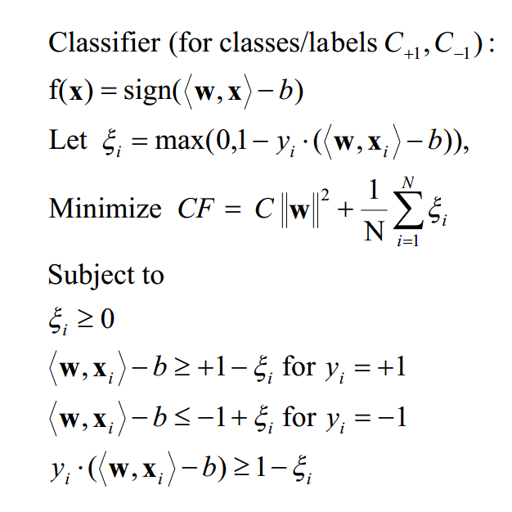

The cost function *CF* has several constraints. Lagrangian multipliers can be used to integrate these constraints into the cost function. *CF* is then optimized, yielding the support vector expansion for the classifier:

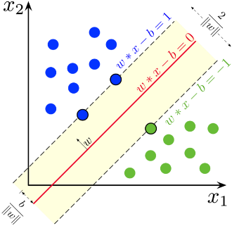

**Figure 3. A schematic diagram showing the Support Vector Machine classifier.**



The linear support vector expansion cannot be used to describe nonlinear relationships between the explanatory and dependent variables. To make the algorithm nonlinear, kernel functions are used to map the data to higher dimensions where they exhibit linear patterns and the linear model can be applied in that feature space (Boser et al. 1992). The radial basis function was used in this study because of its computational efficiency. SVM has one hyperparameter that cannot be determined from optimization: C, which determines the balance between a good separation and flatness, and $γ$, a parameter for the kernel function. Both were determined with a grid search method on the training data.

The Naive Bayes (NB) is a simple probabilistic classifier based on the Bayes’ Rule and requires strong “naïve” independence between the features (Maron 1961, Hand and Yu 2001). It tries to find the best class $C_{k}$ that maximizes $p(C_{k}|x)$, where **x** is a new observation, by using the probability distribution for each of the classes. To do this, it uses Bayes’s rule and attempts to calculate the likelihood. Mathematically, it can be written as

$$p\left(C_{k} | x\right)=\frac{p\left(C_{k}\right)p\left(x | C_{k}\right)}{p\left(x\right)}$$

$$posterior=\frac{prior ×likelihood}{evidence}$$

An assumption of strong naive independence and the probabilistic chain rule are used to transform the likelihood of **x** into the probabilities of each of the features of **x** given a class. For this study, I used the Gaussian NB, which assumes a Gaussian distribution underlies the sample distribution.

$$p\left(C_{k} | x\right)=\frac{p\left(C_{k}\right)}{p\left(x\right)}\prod_{i=0}^{N}{p\left(x_{i} | C_{k}\right)}$$

$$Gaussian Naive Bayes$$

$$p\left(x_{i} | C_{k}\right)=\frac{1}{\sqrt{2πσ_{k}^{2}}}e^{-\frac{{\left(x_{i}-μ_{k}\right)}^{2}}{2σ_{k}^{2}}}$$



**Figure 4. A schematic diagram showing the Artificial Neural Network model.**

To train the Gaussian NB, the data were segmented by the labels and the mean and standard deviation of each of the features for each of the labels were calculated, giving a probability distribution for each of the labels.

Artificial Neural Network (ANN) is based on the feedforward multilayer perceptron architecture, consisting of an input layer, one or more sets of hidden layers, and one output layer (Zhang 2000, Lee et al. 2003, Hsieh 2009). ANN can be turned into an effective classifier by discretizing the network’s output. The basic substructure of Artificial Neural Network is perceptron (**Figure 4**). For all but the input layer, the perceptron has an input (the outputs of the previous layer). The vectors of inputs and the neuron’s weights are multiplied by a dot product. Then, a transfer function is applied to the sum, giving an output for the next layer of perceptrons. Initially, random numbers are assigned to synaptic weights. The neural network is trained, i.e. weights are adjusted, with the training data. There are two main steps to the training of the neural network: forward computation and backpropagation. In forward propagation, input signals are propagated through the network, layer by layer. In backpropagation, the errors are computed for each neuron, and then the local gradients of the network are calculated. Gradient descent is used to adjust the synaptic weights. These steps are repeated until the error reaches below a desired threshold. I used one hidden layer in my ANN model.

I used the programming language R to conduct statistical analyses, train the machine learning algorithms, and visualize the results. The following R packages were used: neuralnet, kernlab, e1071, raster, doParallel, and PBSmapping. They are listed in the references. The programs that I wrote can be found in my github repository: <https://github.com/lim09749/WFS_ML/>.  **3. Results:**

To test the predictive skill of machine learning algorithms, I used a 10-fold cross validation procedure to make a prediction for new testing data not used in training. First, the data were randomly divided into 10 equal sized partitions. For every partition, each machine learning algorithm was trained on the other nine partitions and produced a prediction on the partition. This process was repeated for all ten partitions. The following metrics were used to evaluate model performance: accuracy during weeks with a *K. brevis* bloom, accuracy during weeks without a bloom, and the total accuracy. The averaged metrics over 10 partitions are displayed in **Table 1.** SVM performed the best, with 63% accuracy for weeks with HABs, 85% accuracy for weeks without HABs,

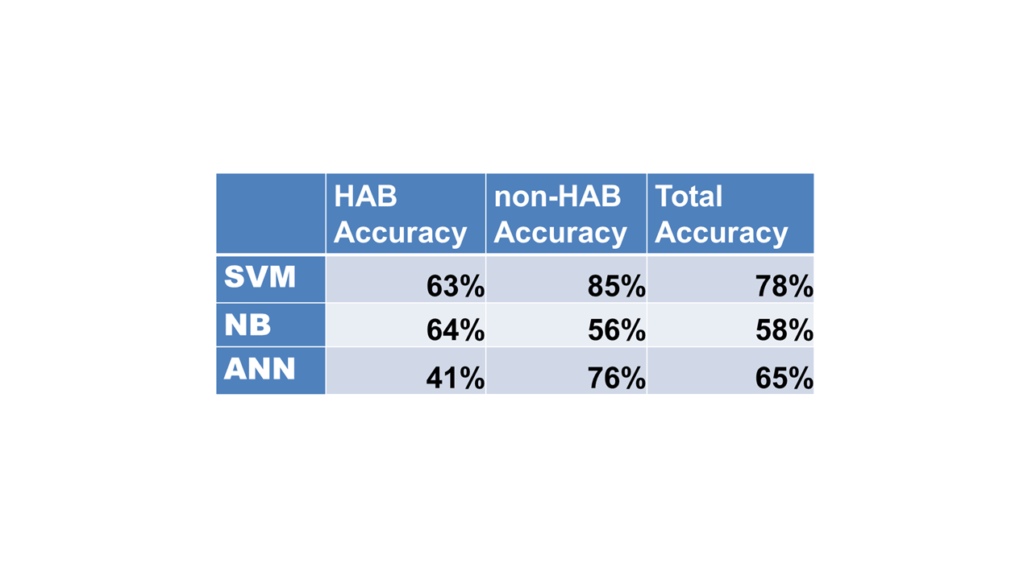

**Table 1. Performance of the Support Vector Machine (SVM), Naive Bayes (NB), and Artificial Neural Network (ANN).**

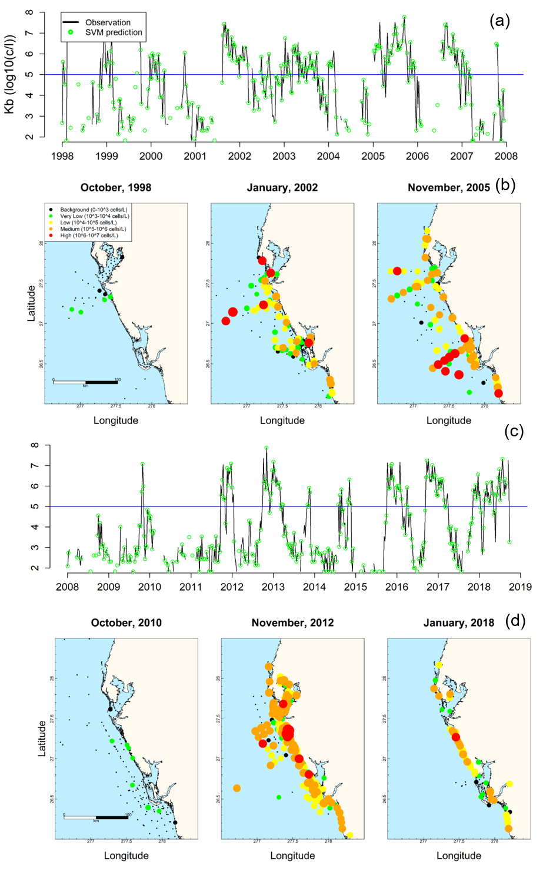

**Figure 5. Time series of the observed (black line) and predicted (green open circles) area-averaged *K. brevis* concentrations for 1998-2008 (a) and 2008-2018 (c). Snapshots of the observed *K. brevis* distribution in selected months and years during 1998-2008 (b) and 2008-2018 (d).**

and 78% for the total accuracy. ANN ranked second (64%; 56%; 58%), and computationally efficient NB had the lowest accuracy (41%; 76%; 65%).

To give further details on the SVM performance, I created the time series of the predicted *K. brevis* blooms and compared with the observed cell concentration for 20 years (1998-2018) (**Figures 5a, 5c**). Weekly averages of the observed *K. brevis* cell counts were plotted as the black line. If SVM predicted blooms correctly, a green dot was placed on the observed weekly average. Overall, there is a very good agreement between the predicted and observed *K. brevis* bloom events. Between 1998 and 2018, there were years with large blooms, such as January 2002 and November 2005 (**Figure 5b**) and November 2012 and January 2018 (**Figure 5d**). No blooms appeared in some years, with examples shown in October 1998 and October 2010 (**Figures 5b, 5d**). Some blooms lasted for a prolonged period while others had particularly high cell counts. For example, the bloom in 2005 lasted for nearly a year and had some of the highest cell densities. In the fall and winter 2012-2013, *K. brevis* cell density reached historically high concentration but only lasted for a few months. The recent bloom was initiated in the fall of 2017 and had continued until the end of 2018. The spatial distribution of blooms also varied. For example, the bloom in November 2012 extended across the entire shelf in the central region whereas the bloom in January 2018 was mostly confined to the coast. Since data sampling was insufficient to develop a spatially explicit HABs model, this study focused on predicting area-averaged *K. brevis* bloom outbreaks.

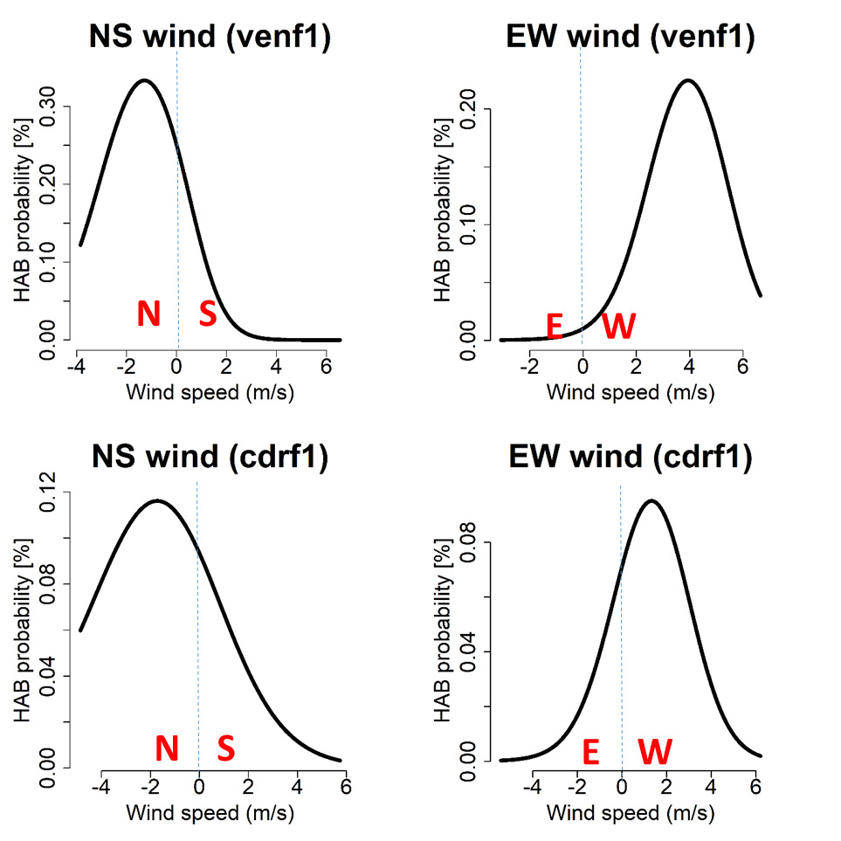

**Figure 6. HAB probability as a function of wind speed and direction at buoy stations venf1 and cdrf1.**

(d)

(c)

(b)

(a)

In addition to developing a classifier to predict *K. brevis* outbreaks, I used machine learning algorithms to gain new insights into the factors that affect *K. brevis* blooms. I trained SVM on the entire dataset and calculated the probability of *K. brevis* bloom occurrence using the Platt scaling:

$P\left(y_{i}=C_{+1} | x\right)=\frac{1}{1+\exp\left(Af\left(x\right)+B\right)}$

where $y_{i}$ is a sample, $C_{+1}$ is one of the classes, $f\left(x\right)$ is the SVM output, and A and B are constants (Platt 1999). The Platt scaling converts classifier predictions into probability distributions for each class.

In **Figure 6** I plotted the HABs probability as functions of wind speed components in the north-south direction (negative for northerly wind) and the east-west direction (negative for easterly wind). To create these line plots, a particular feature (i.e. a wind speed component) was varied while the others (river flows and temperature) were set to the mean during the fall-winter season. The feature was varied over two standard deviations below and above the mean. I chose two buoy stations venf1 and cdrf1located near the Coast (where HABs are most commonly found), but results from the other buoys were about the same. At both buoy stations, the bloom probability is much higher under northerly winds than under southerly winds (**Figure 6a, c**). Northerly winds drive offshore transport on WFS and coastal upwelling, thereby transporting *K. brevis* from the offshore waters to coastal waters in the bottom layer. Once *K. brevis* reaches nearshore locations, westerly winds help to hold *K. brevis* blooms against the shore and prevents them from dispersing offshore (**Figure 6b, d**). This confirms my first hypothesis that northerly winds produce upwelling conditions favorable for *K. brevis* blooms.

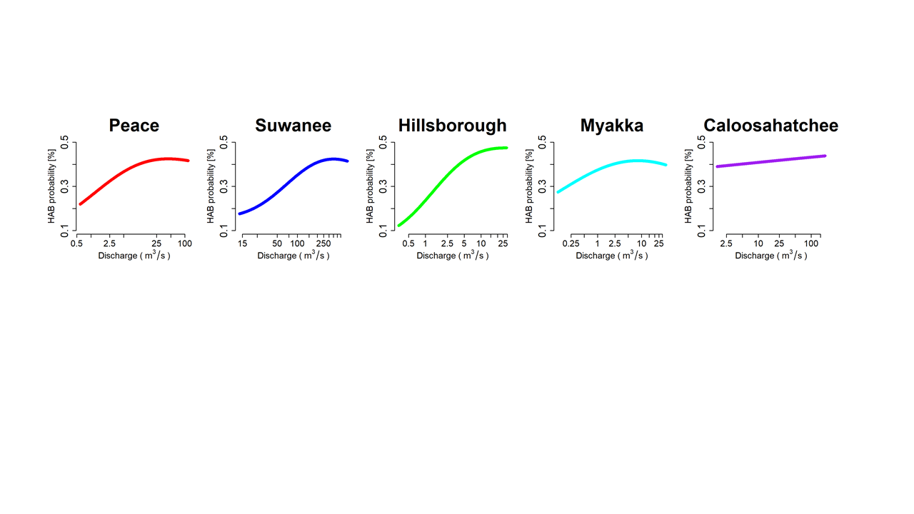

**Figure 7. HABs probability as a function of discharge from the Peace, Suwanee, Hillsborough, Myakka and Caloosahatchee Rivers.**

**Figure 7** shows HABs probability as a function of flows at the Peace, Suwanee, Hillsborough, Myakka and Caloosahatchee Rivers. The HABs probability increases as the river discharge increases. These rivers provide nutrients like nitrogen and phosphorous that feed *K. brevis* blooms. However, different rivers have different effects on the HABs occurrence probability. Hillsborough River has the strongest influence, with the HABs occurrence increasing 5-fold from low to high river flows. In contrast, the Caloosahatchee River has relatively weak influence, with the HABs probability only increasing by 10%. This result confirms my second hypothesis that river flows provide a major source of nutrients for fueling *K. brevis* blooms.

The trained SVM model was also used to test the relationship between *K. brevis* blooms and total nitrogen (TN) or total phosphorous (TP) loading from the rivers where nutrient concentration data were available **(Figure 8)**. The HABs occurrence probability mostly increases with TN loading, but different rivers have different effects: increasing TN in Hillsborough/Peace River results in 200%/50% increase in bloom occurrence whereas increasing TN in Caloosahatchee/Myakka River results in 15% decrease in bloom probability or no significant effect. The HABs occurrence probability increases with TP loading in Hillsborough and Caloosahatchee Rivers but is a parabolic function of TP loading from Myakka and Peace Rivers. The analysis mostly confirms my second hypothesis: Larger nutrient loading leads to more frequent *K. brevis* bloomssince larger nutrient loading associated with higher nutrient concentration provides more fuel for the HABs growth. The exceptions indicates that *K. brevis* response to riverine nutrient loading is complex and requires further mechanistic investigations beyond the statistical analysis presented here.

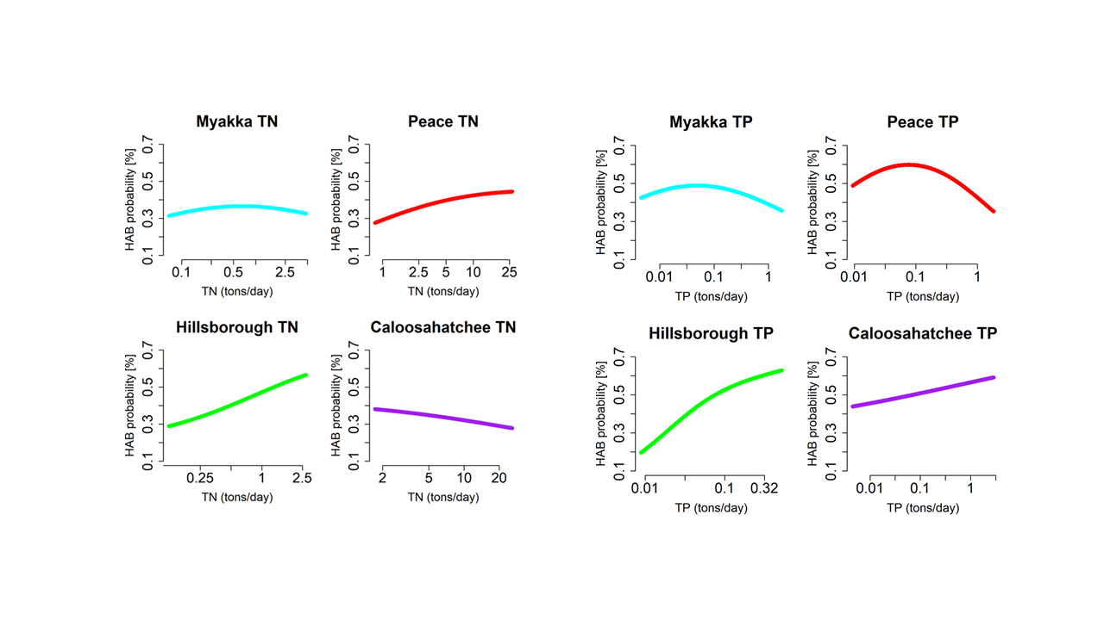

**Figure 8. Contours plots of HAB probability as a function of total nitrogen loading (TN) and total phosphorous loading (TP) from four rivers.**

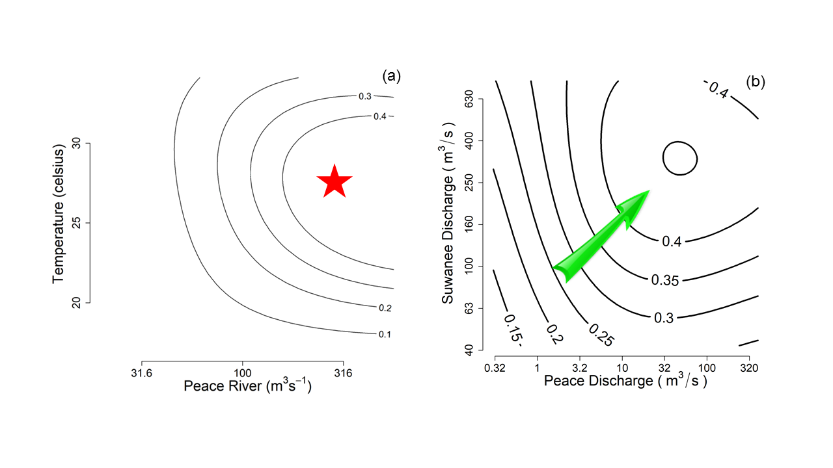

**Figure 9. Contours plots of HAB probability as a function of river discharge from and temperature and Peace River discharge (a) and the Peace and Hillsborough River (b).**

**4.** **Discussion:**

Based on the machine learning analysis of long term monitoring data, we can assess how climate change and nutrient management strategies may affect the occurrence of *K. brevis* blooms on WFS in the future. According to the Intergovernmental Panel on Climate Change (IPCC) report, air temperature over the Eastern North America (including Florida) will increase ~1.5 oC by 2050 and 3-4 oC by 2100 (relative to 2000). Rainfall over Florida is projected to decrease by 20-30% during the summer but increase by 10-20% during the fall-winter. Since river drainage basins are large, a 10-20% increase in fall-winter rainfall (typical *K. brevis* bloom season) will translate into large increases in river flows. To examine the impacts of climate change, I calculated HABs occurrence probability as a function of river flows and temperature. **Figure 9a** shows that bloom occurrence increases with Peace River flow but reaches a maximum around 27 oC. Like other plankton species, *K. brevis* has an optimal temperature range (25-28 oC) for maximum growth. Currently, *K. brevis* blooms typically occur between September and January in the following year. Warming may shift the bloom period later (October to February). I also investigated how the HABs probability varies with two river flows: Peace River and Suwanee River **(Figure 9b)**. With increasing precipitation and larger river flows in the future climate, there will be more *K. brevis* blooms. This analysis addresses my third hypothesis: Increasing precipitation in a changing climate will lead to more frequent HABs outbreaks on the West Florida Shelf.

Federal and state agencies have established nutrient reduction targets to mitigate water quality problems around the U.S. For example, 20% reduction in nutrient loading has been set for the Gulf of Mexico and Chesapeake Bay. I examined how the HABs occurrence probability varies with total nitrogen loading (TN) in two rivers (Peace River and Hillsborough River) **(Figure 10a)**. Reducing TN loading will indeed decrease bloom occurrence, but larger reductions are needed to have a substantial effect. I also investigated how the HABs occurrence probability varies with total nitrogen loading (TN) and total phosphorous loading (TN) in Hillsborough River **(Figure 10b)**. Reducing TN and TP loading together will have a bigger effect on reducing *K. brevis* blooms than reducing TN or TP loading alone.

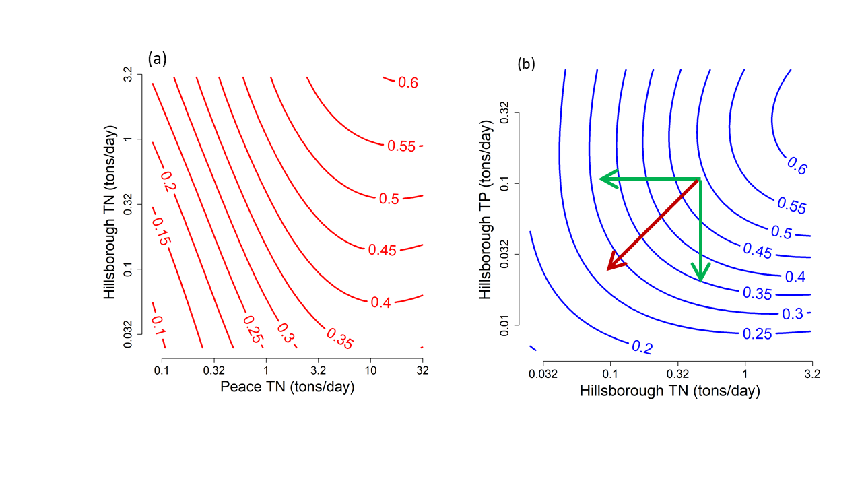

**Figure 10. HABs occurrence probability as a function of TN loading from Peace and Hillsborough Rivers (a) and TN and TP loading from Hillsborough River (b).**

**5.** **Conclusions:**

In this study, I have developed three machine learning classifiers to predict the outbreaks of the toxic *K. brevis* blooms on WFS: Support Vector Machine, Artificial Neural Network, and Naive Bayes. SVM had the highest classification accuracy, with 63% accuracy for weeks with HABs, 85% accuracy for weeks without HABs, and 78% for the total accuracy. ANN and NB have lower accuracies. My analysis confirms my three hypotheses: (1) northerly winds produce upwelling conditions favorable for *K. brevis* blooms; (2) river flows provide a major source of nutrients fueling *K. brevis* blooms; (3) increasing precipitation in a warming climate will lead to more frequent HABs on WFS in the future. My analysis further shows that reducing total nitrogen loading and total phosphorous loading together will be more effective in mitigating blooms than reducing TN or TP alone.

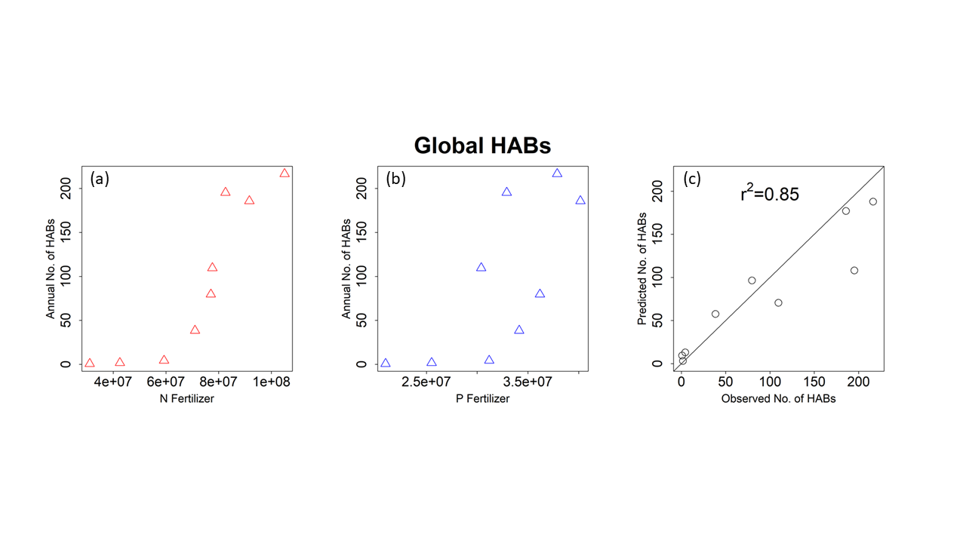

**Figure 11. Annual number of HABs events in global oceans as a function of the nitrogen (a) and phosphorous (b) fertilizer uses around the world. (c) The predicted (from a Support Vector Regression model) versus observed annual number of HABs in global oceans.**

HABs have been increasing around the world over the past 5 decades, with the longest records in North America and Europe. In recent years HABs have shown even more dramatic increases in Asia and Africa (data downloaded from UNESCO Harmful Algal Bloom Programme at <http://hab.ioc-unesco.org/index.php?option=com_content&view=article&id=49:harmful-algal-blooms-for-policy-makers&catid=11:geohab>). **Figures 11 (a) and (b)** show how the annual number of HABs in global oceans is related to the nitrogen or phosphorous fertilizer use in the world. HABs are clearly linked to eutrophication resulting from agricultural use of fertilizers and sewage disposal, but the relationship between HABs and nutrient loading is complicated. The machine learning models - Support Vector Regression was able to capture this nonlinear relationship, with the correlation coefficient between the predicted and observed number of HABs in global oceans reaching 0.85 **[Figure 11(c)]**. Therefore, the machine learning approaches I have developed for the West Florida Shelf could be extended in the future to make HABs predictions in coastal oceans around the world.

**6.** **References:**

Anderson, D.A., Glibert, P.M., Burkholder, J.M. 2002. Harmful algal blooms and eutrophication: Nutrient sources, composition, and consequences. *Estuaries* 25: 562-584.

Backer, L.C., McGillicuddy, D.J. 2015. Harmful algal blooms at the interface between coastal oceanography and human health. *Oceanography* 19(2): 94-106. doi: 10.5670/oceanogr.2006.72.

Boser, Bernhard E.; Guyon, Isabelle M.; Vapnik, Vladimir N. 1992. A training algorithm for optimal margin classifiers. Proceedings of the fifth annual workshop on Computational learning theory – COLT '92. p. 144. [doi](https://en.wikipedia.org/wiki/Digital_object_identifier):[10.1145/130385.130401](https://doi.org/10.1145%2F130385.130401).

Brand, K. and A. Compton. 2007. Long-term increase in Karenia Brevis abundance along the southwest Florida coast. *Harmful Algae*, 6, 232-252.

Burkholder, J.M., Shumway, S.E., Glibert, P.M. 2018. Food webs and ecosystem impacts of harmful algae. In: Shumway, S., J.M. Burkholder and S.L. Morton (eds.), *Harmful Algal Blooms: A Compendium Desk Reference*. Wiley. pp. 243-336

Cortes, C., and Vapnik, V. 1995. Support-vector networks. *Machine Learning*, 20(3), 273-297.

Fleming, L.E. et al. 2011. Review of Florida red tide and human health effects. *Harmful Algae*, 10(2), 224-233.

Fritsch, S., and Guenther, F. 2016. neuralnet: Training of Neural Networks. R package version 1.33. https://CRAN.R-project.org/package=neuralnet.

Glibert, P.M., Seitzinger, S., Heil, C.A., Burkholder, J.M., Parrow, M.W., Codispoti, L.A., Kelly, V. 2005. The role of eutrophication in the global proliferation of harmful algal blooms: new perspectives and new approaches. *Oceanography* 18(2):198-209.

Glibert, P.M., Allen, J.I., Bouwman, L., Brown, C., Flynn, K.J., Lewitus, A., Madden, C. 2010. Modeling of HABs and eutrophication: status, advances, challenges*. J. Mar. Syst*. 83: 262-275.

Glibert, P.M., Burford, M.A. 2017. Globally changing nutrient loads and harmful algal blooms: Recent advances, new paradigms and continuing challenges. *Oceanography* 30(1): 44-55.

Hand, D. J.; Yu, K. 2001. Idiot's Bayes — not so stupid after all?. International Statistical Review. 69 (3): 385–399. [doi](https://en.wikipedia.org/wiki/Digital_object_identifier):[10.2307/1403452](https://doi.org/10.2307%2F1403452).

Haverkamp, D., Steidinger, K.A., Heil, C.A. 2004. HAB monitoring and databases: the *Karenia brevis* example. In: Hall, S., Etherrdge, S., Anderson, D., Zhu, M., Zou, Y. (Eds.), Harmful Algae Management and Mitigation, Asia-Pacific Economic Cooperation, Singapore (APEC Publication#204-MR-04.2).

Heil, C.A., Steidinger, K.A. 2009. Monitoring, management, and mitigation of *Karenia* blooms in the eastern Gulf of Mexico. *Harmful Algae,* 8, 611-617.

Heil, C.A., Bronk, D.A., Dixon, L.K., Hitchcock, G.L., Kirkpatrick, G.J., Mulholland, M.R., O’Neil, J.M., Walsh, J.J., Weisberg, R., Garrett, M. 2014. The Gulf of Mexico ECOHAB: *Karenia* Program 2006–2012. *Harmful Algae,* 38, 3-7.

Heisler, J., Glibert, P.M., Burkholder, J.M. *et al.* 2008. Eutrophication and harmful algal blooms: A scientific consensus. *Harmful Algae* 8: 3-13.

Hijmans, R. 2017. raster: Geographic Data Analysis and Modeling. R package version 2.6-7. https://CRAN.R-project.org/package=raster.

Hsieh, W.W. 2009. *Machine Learning Methods in the Environmental Sciences: Neural Networks and Kernels*. Cambridge University Press. ISBN-13: 978-0805822410.

Hu, C., F.E. Muller-Karger, and P. W. Swarzenski. 2006. Hurricanes, submarine groundwater discharge, and Florida’s red tides. *Geophysical Research Letters*, 33, L11601, dpi: 10.1029/2005GL0254449.

IPCC, Summary for policymakers, in Climate Change 2014: Impacts, Adaptation, and Vulnerability. Part A: Global and Sectoral Aspects. Contribution of Working Group II to the Fifth Assessment Report of the Intergovernmental Panel on Climate Change, C. B. Field, V. R. Barros, D. J. Dokken, K. J. Mach, M. D. Mastrandrea, T. E. Bilir, M. Chatterjee, K. L. Ebi, Y. O. Estrada, R. C. Genova, B. Girma, E. S. Kissel, A. N. Levy, S. MacCracken, P. R. Mastrandrea, L. L. White, Eds. (Cambridge Univ. Press, 2014), pp. 1–32.

Karatzoglou, A., Smola, A., Hornik, K., Zeileis, A. 2004. Kernlab - An S4 Package for Kernel Methods in R. Journal of Statistical Software 11(9), 1-20. URL http://www.jstatsoft.org/v11/i09/.

Kirtman, B.P., V. Mirsa, A. Anandhi, D. Palko, J. Infanti. 2017. Future climate change scenarios for Florida, Chapter 18. FSU_libsubv1_scholarship_submission_1515511768_f4ca0fd1 (IID), doi: [10.17125/fci2017.ch18](https://doi.org/10.17125/fci2017.ch18).

Kostsiantis, S.B. 2007. Supervised machine learning: a review of classification techniques. *Informatica*, 31, 249-268.

Landsbery, J.H., Flewelling, L.J., Naar, J. 2009. *Karenia brevis* red tides, brevetoxins in the food web, and impacts on natural resources: decadal advancements. *Harmful Algae* 8:598-607.

Lee, J. H. W., Huang, Y., Dickman, M. and Jayawardena, A. W., 2003. Neural Network Modelling of Coastal Algal Blooms. *Ecol. Model.* 159: 179-201.

Lenes, J.M., B.A Darrow, J.J. Walsh, J.M. Prospero, R. He, R.H. Weisberg, G.A. Vargo, and C.A Heil. 2008. [Saharan dust and phosphatic fidelity: A three-dimensional biogeochemical model of Trichodesmium as a nutrient source for red tides on the West Florida Shelf](http://dx.doi.org/10.1016/j.csr.2008.02.009), *Cont. Shelf Res.*, 28, 1091-1115.

Liu, Y. and R. H. Weisberg. 2012. Seasonal variability on the West Florida Shelf. *Progress in Oceanography*, 104, 80-98.

Liu, Y., R.H. Weisberg, J.M. Lenes, L. Zheng, K. Hubbard, and J.J. Walsh. 2016. [Offshore forcing on the "pressure point" of the West Florida Shelf: Anomalous upwelling and its influence on harmful algal blooms](http://dx.doi.org/10.1002/2016JC011938), *Journal of Geophysical Research*, 121, 5501-5515.

Maron, M. E. 1961. ["Automatic Indexing: An Experimental Inquiry"](http://delivery.acm.org/10.1145/330000/321084/p404-maron.pdf?ip=146.244.117.157&id=321084&acc=ACTIVE%20SERVICE&key=F26C2ADAC1542D74%2E144ADCEE99EDDC29%2E4D4702B0C3E38B35%2E4D4702B0C3E38B35&__acm__=1551394905_96b60790765feedd11602dd1dfde40dd) (PDF). [*Journal of the ACM*](https://en.wikipedia.org/wiki/Journal_of_the_ACM), 8 (3): 404–417. [doi](https://en.wikipedia.org/wiki/Digital_object_identifier):[10.1145/321075.321084](https://doi.org/10.1145%2F321075.321084).

Maze, G., M.J. Olascoaga and L. Brand. 2015. Historical analysis of environmental conditions during Florida red tide. *Harmful Algae*, 50, 1-7.

Meyer, D., Dimitriadou, E., Hornik, K., Weingessel, A., and Leisch, F. 2018. e1071: Misc Functions of the Department of Statistics, Probability Theory Group (Formerly: E1071), TU Wien. R package version 1.7-0. <https://CRAN.R-project.org/package=e1071>.

Microsoft Corporation and Weston, S. 2017. doParallel: Foreach Parallel Adaptor for the 'parallel' Package. R package version 1.0.11. <https://CRAN.R-project.org/package=doParallel>.

Pebesma, E., Bivand, R. 2005. Classes and methods for spatial data in R. RNews 5 (2), https://cran.r-project.org/doc/Rnews/.

[Platt, J.](https://en.wikipedia.org/wiki/John_Platt_(computer_scientist)) 1999. [Probabilistic outputs for support vector machines and comparisons to regularized likelihood methods](https://www.researchgate.net/publication/2594015). Advances in Large Margin Classifiers, **10** (3): 61–74.

R Core Team. 2017. R: A language and environment for statistical computing. R Foundation for Statistical Computing, Vienna, Austria. URL <https://www.R-project.org/>.

Schnute, J., Boers, M., and Haigh, R. 2017. PBSmapping: Mapping Fisheries Data and Spatial Analysis Tools. R package version 2.70.4. https://CRAN.R-project.org/package=PBSmapping.

Sinha, E., A.M. Michalak, and V. Balaji. 2017. Eutrophication will increase during the 21st century as a result of precipitation changes. *Science*, 357, 405-408.

Steidinger, K.A. 2009. Historical perspective on *Karenia brevis* red tide research in the Gulf of Mexico. *Harmful Algae,* 8, 549-561.

Stump R.P. et al. 2003. Monitoring Karenia Brevis blooms in the Gulf of Mexico using satellite ocean color imagery and other data. *Harmful Algae*, 2, 147-160.

Stump, R.P., et al. 2009. Skill assessment for an operational algal bloom forecast system. *Journal of Marine System*, 76(1-2), 151-161.

U.S. Geological Survey, 2018, Water-Quality Data for Florida, accessed December 2018, 2018 at URL <https://waterdata.usgs.gov/fl/nwis/qw/>.

Vargo, G.A. et al. 2008. Nutrient availability in support of *Karenia brevis* blooms on the central west Florida Shelf: What keeps *Karenia* blooming? *Continental Shelf Research* 28: 73-79.

Visser, N. August 15, 2018. Florida declares state of emergency as red tide spreads. *Huffington Post.* <https://www.huffingtonpost.com/entry/red-tide-florida-state-ofemergency_>us_5b73c40fe4b02b415d73affe.

Walsh, J.J. et al. 2006. Red tides in the Gulf of Mexico: where, when, and why. *Journal of Geophysical Research* 111 (C11003), http://dx.doi.org/10.1029/2004JC002813.

Wei Haas, M., Depp, B. Aug. 8, 2018. Red tide is devastating Florida’s sea life. Are humans to blame? *National Geographic*. https://www.nationalgeographic.com/ environment/2018/08/news-longest-redtide- wildlife-deaths-marine-life-toxins/.

Weisberg, L., Zheng, Y., Liu, C., Lembke, J.M., Lenes, J.J., Walsh. 2014. Why a Red Tide was not observed on the West Florida Continental Shelf in 2010. *Harmful Algae,* 38, 119-126.

Zhang, G. 2000. Neural networks for classification: a survey. *IEEE Transactions on Systems, Man, and Cybernetics*, Part C 30 (4), 451-462.